COAL Assignment 01:
BSCS-3D
22F-3441
Code 1:
org 0x100
jmp start
data:dw 1,2,3,4,5,6,7,8,9,0
swap:db 0
start:mov bx,0
mov byte[swap],0
loop1:mov ax,[data+ax]
cmp ax,[data+bx+2]
jbe noswap
mov dx,[data+bx+2]
mov[data+bx+2],ax
mov[data+bx],dx
move byte[swap],1
noswap:add bx,2
cmp bx,18
jne loop1
cmp byte[swap],1
mov bx , 0x4c00
int 0x21
OUTPUT:
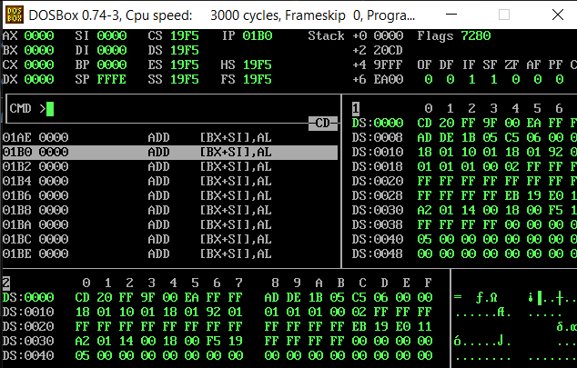
CODE 2:
org 0x100
mov ax , 20

cmp ax ,0
je eq
jg pve
jl nve

pve: mov bx , 1
nve: mov bx , -1
eq: mov bx , 0

mov ax , 0x4c00
int 0x21
OUTPUT:
